

AMERICAN INTERNATIONAL UNIVERSITY BANGLADESH (AIUB)
FACULTY OF SCIENCE & TECHNOLOGY

DEPARTMENT OF COMPUTER SCIENCE AND ENGINEERING
Fall 2025-26
Section: O
Course: COMPUTER ORGANIZATION AND ARCHITECTURE

Performance Tasks

Supervised By SHANDIPAN PAUL

Submitted By

SN | Name | ID
1 | Afnan Bin Islam Nahin | 22-49350-3

Date of Submission: 6.1.2026

Task for assembly_jump_questions.pdf

QUESTION 1: Uses A=30, B=10. Compare using unsigned (JA, JB) and signed (JG, JL).

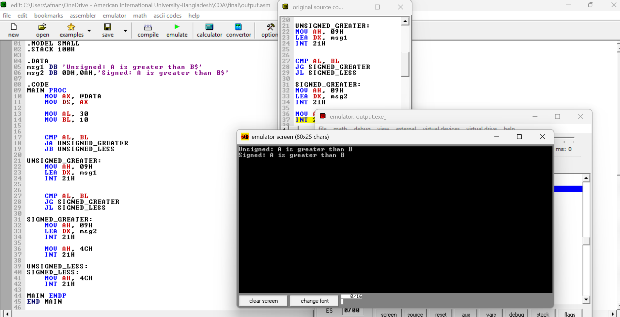

QUESTION 2: Uses X=200, Y=100. Compare using JAE, JBE, JGE, JLE.

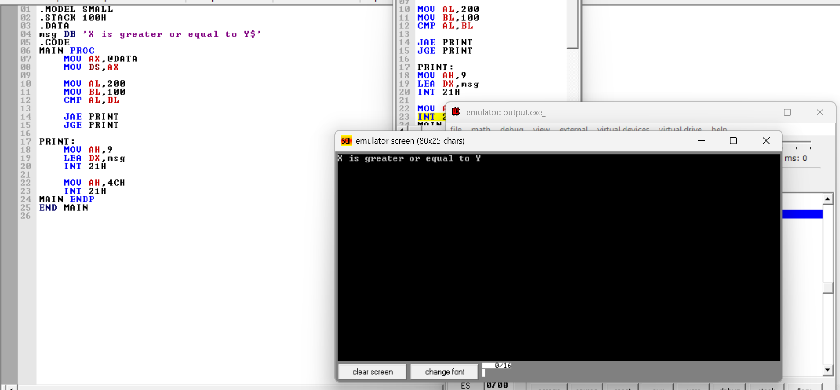
QUESTION 3: Uses M=5, N=250. Compare using JB, JAE, JG, JL.

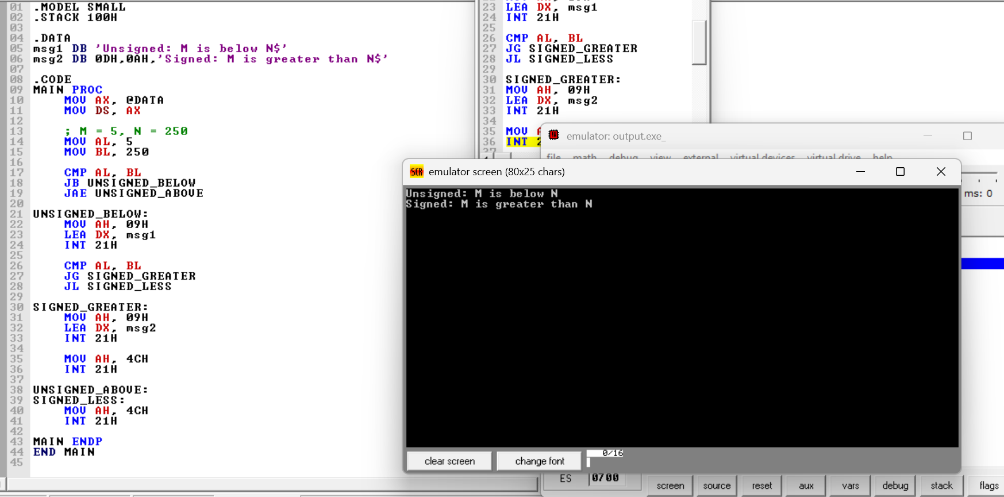

QUESTION 4: Uses P=-5, Q=3. Compare using JL, JG, JA, JB.

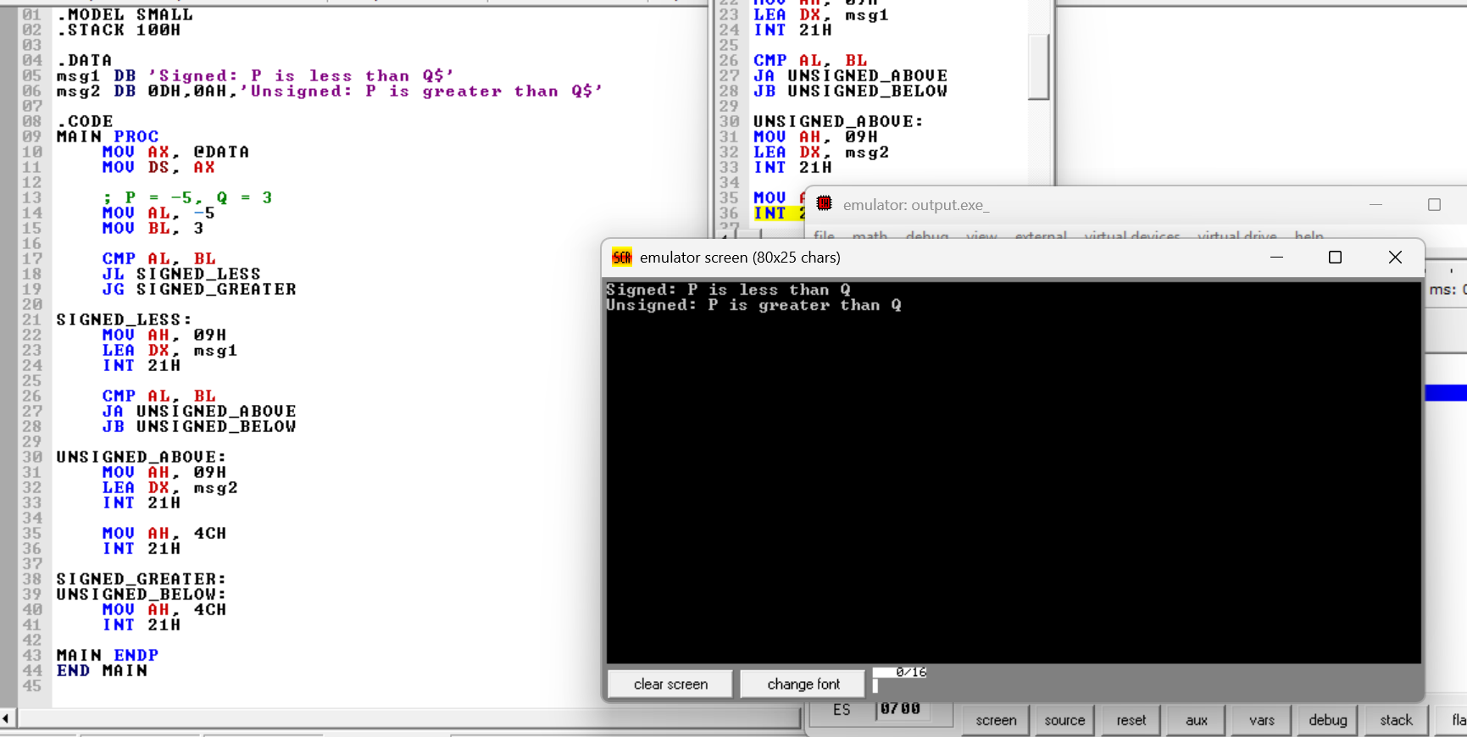

QUESTION 5: Uses U=100, V=100. Compare using JE, JNE, JGE, JLE.

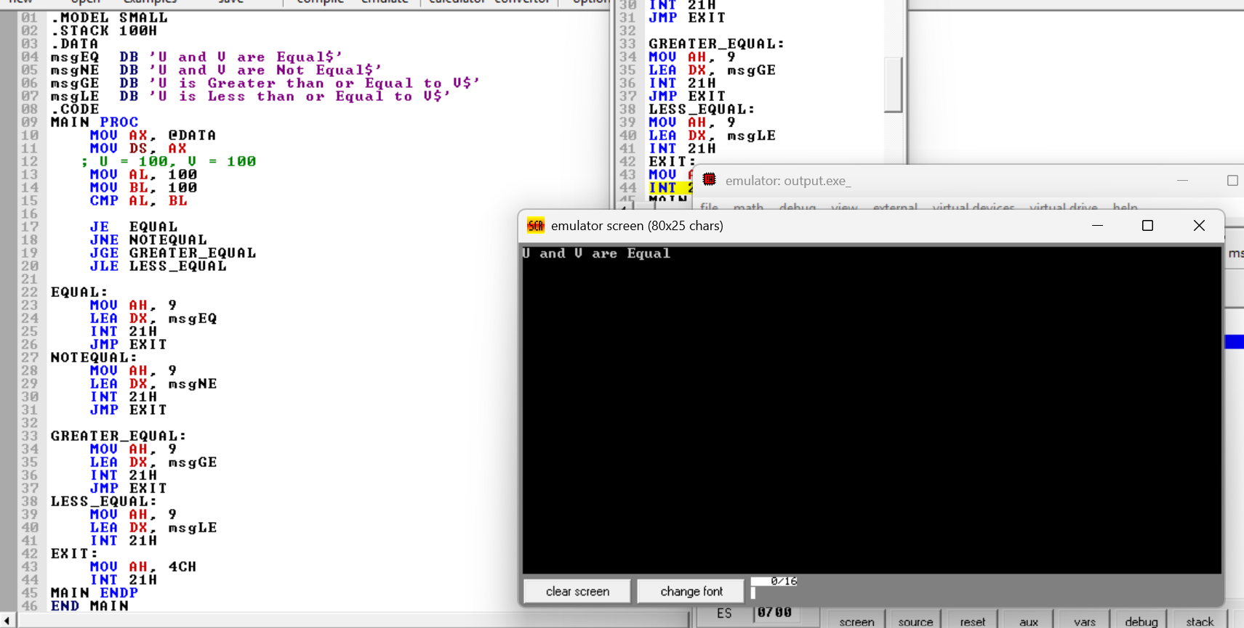

QUESTION 6: Uses D=0FFH, E=1. Compare using JA, JB, JG, JL.

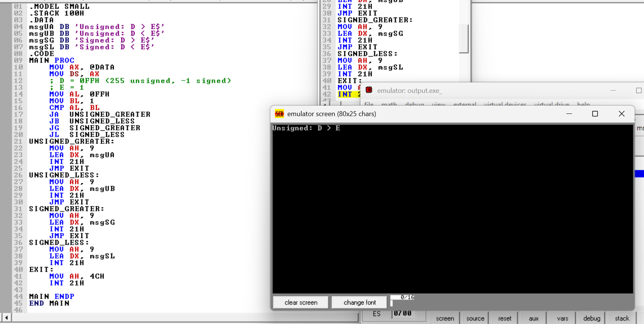

QUESTION 7: Uses R=-10, S=-10. Compare using JE, JNE, JG, JL

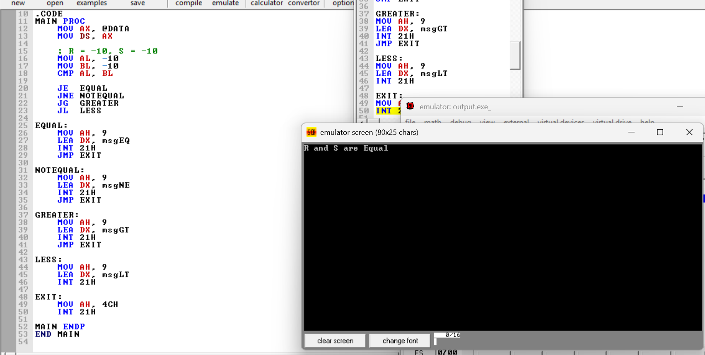

QUESTION 8: Uses A=7, B=20, C=7. Compare using JB, JG, JL.

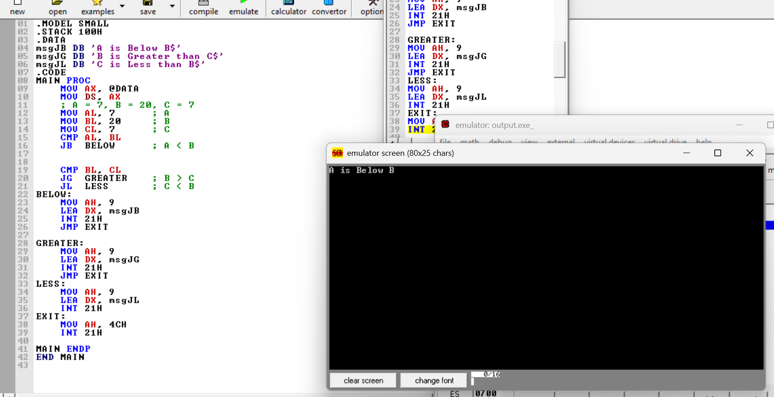

QUESTION 9: Uses L=128, K=2. Compare using JA, JB, JG, JL.

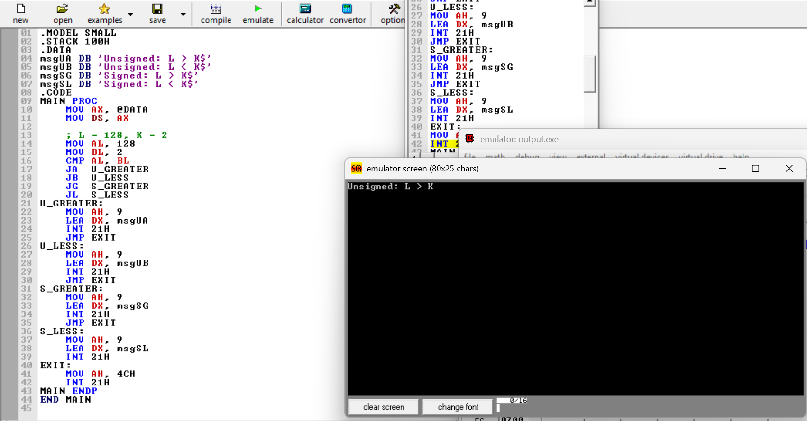

QUESTION 10: Uses num1=-50, num2=200. Compare using JL, JA, JB.

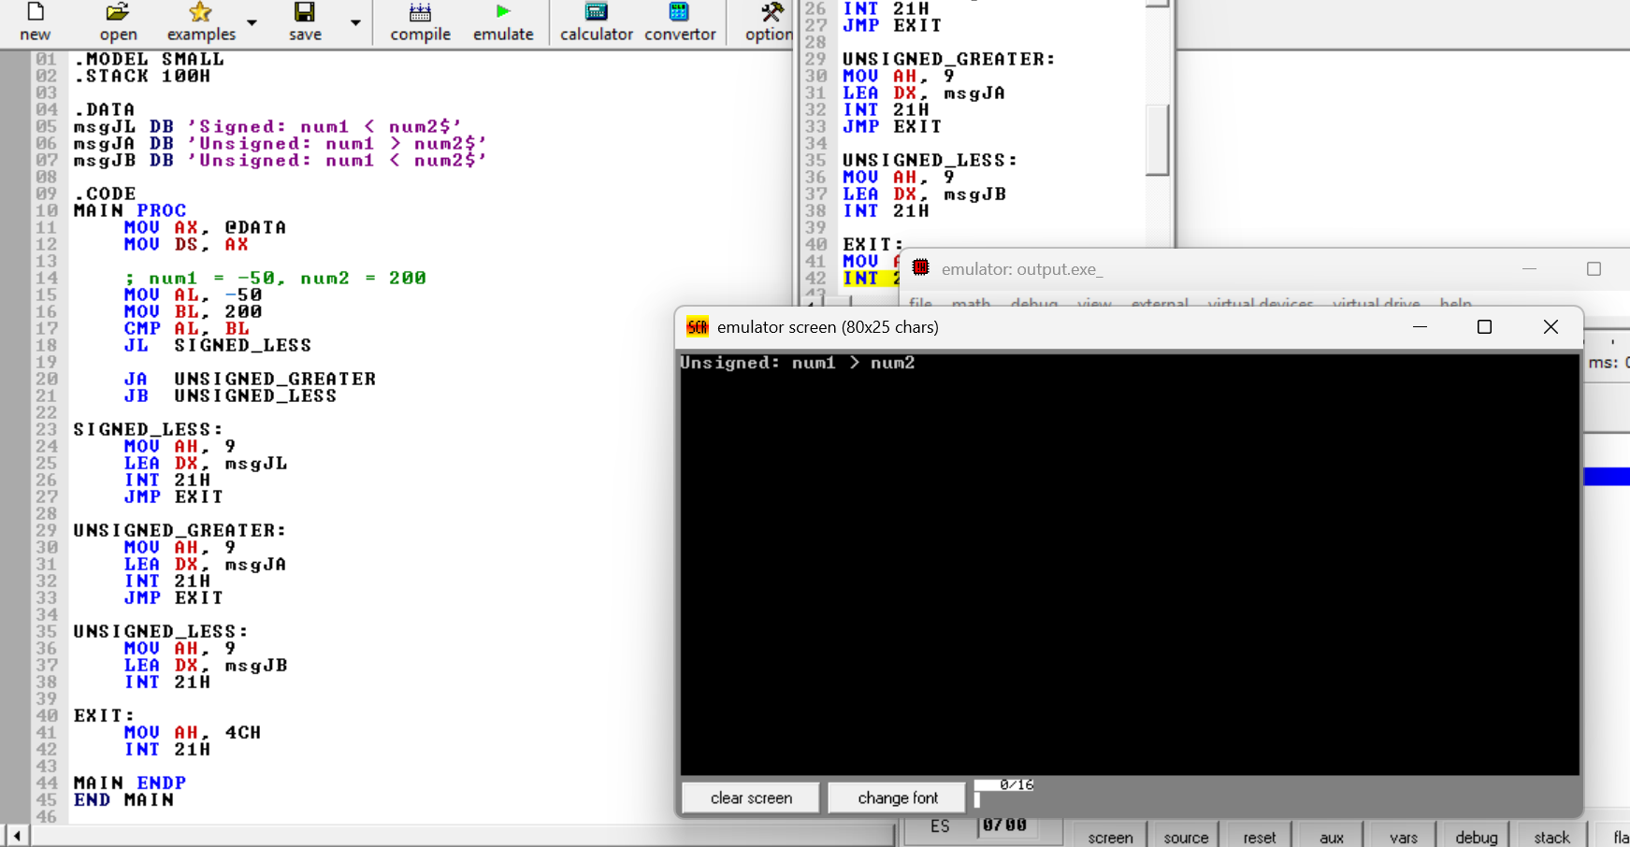

Tasks for G_Today.pdf

Code Tasks:
1. Write an 8086 assembly program that reads a character and prints it only if it is '1' or '2'; otherwise
terminate.
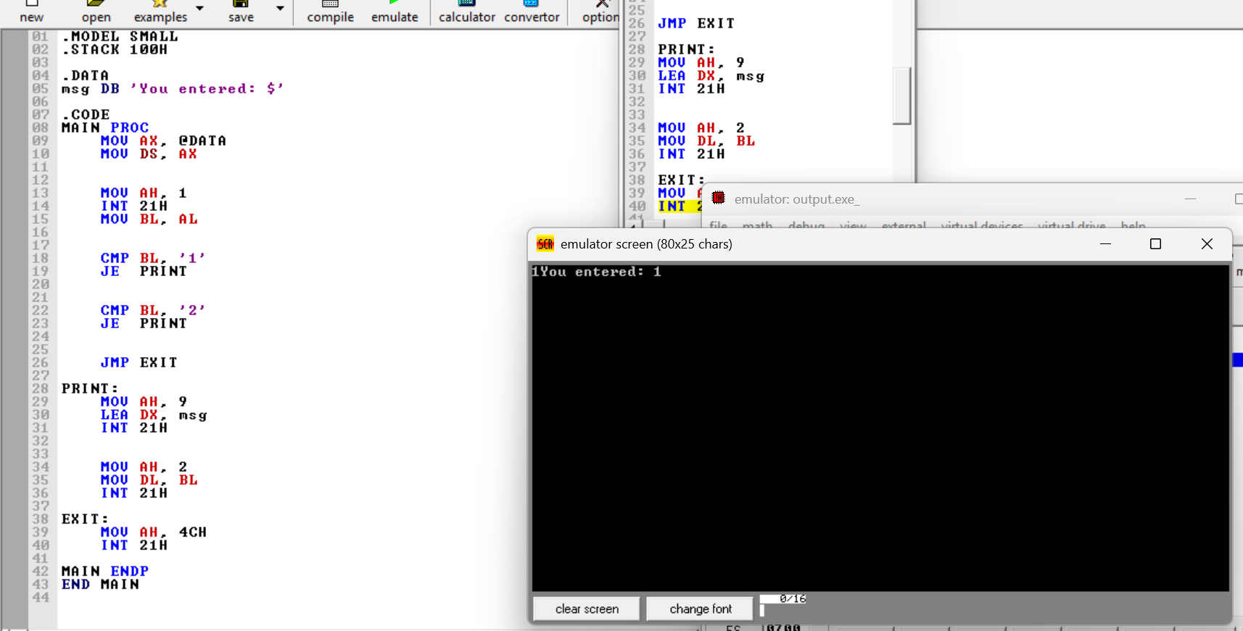

2. Write an 8086 assembly program using a WHILE loop to count vowels until a period '.' is typed.
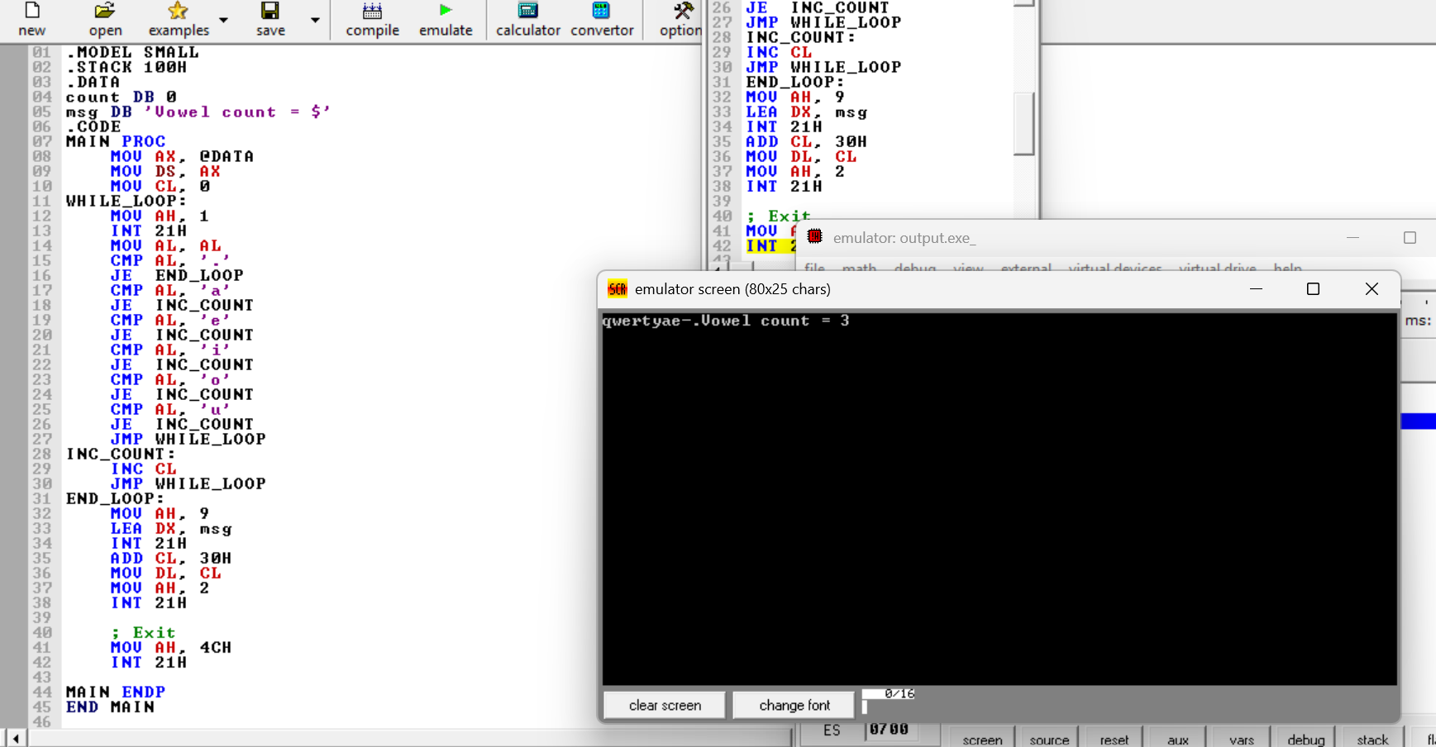

3. Write a FOR-loop based 8086 program that takes input N and prints '#' N times.
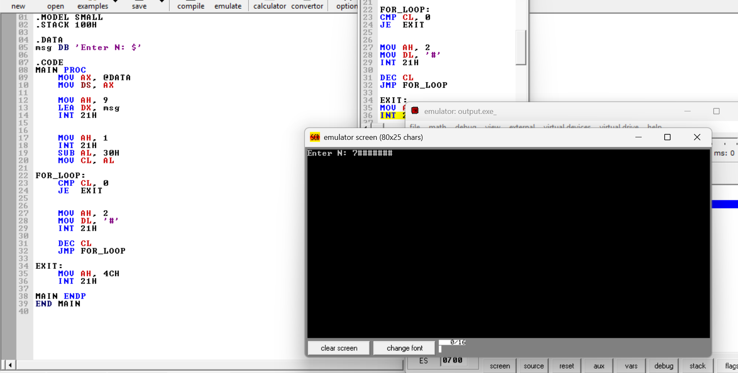

Tasks for G_Today2.pdf

1. Write an assembly program that reads a single character and classifies it as: - Uppercase letter Lowercase letter - Digit - Special character Use compound AND/OR conditions and display the appropriate category.

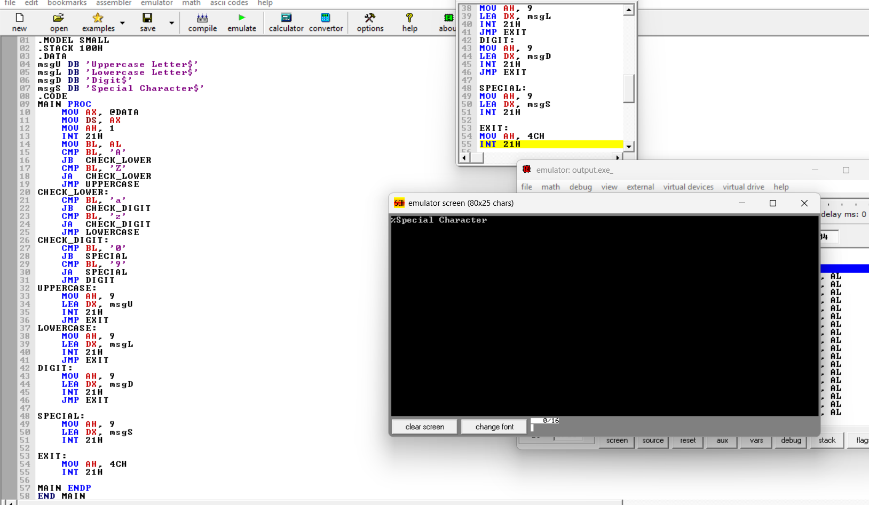

2. Write an assembly program that takes input for number of rows and columns and prints a rectangle of '*' characters. - Use nested FOR loops implemented using LOOP instruction - Use JCXZ to prevent unwanted looping when count is zero

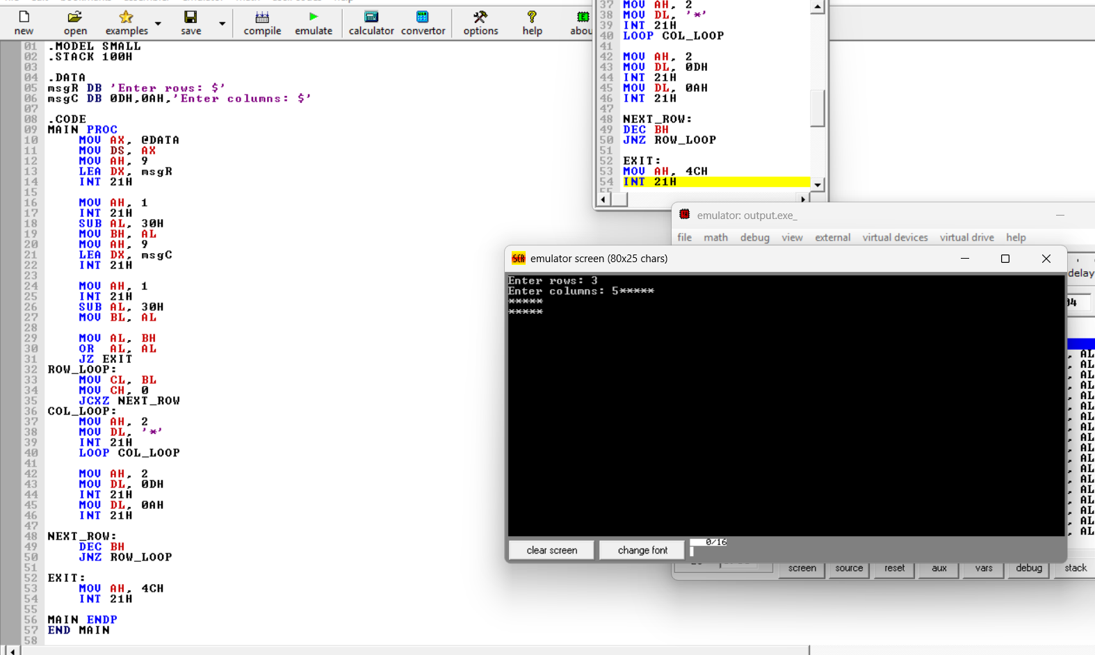

3. Write an assembly program using a WHILE loop to count vowels in a line of text. - Read characters until a carriage return (0Dh) - Count both uppercase and lowercase vowels - Display the total vowel count at the end
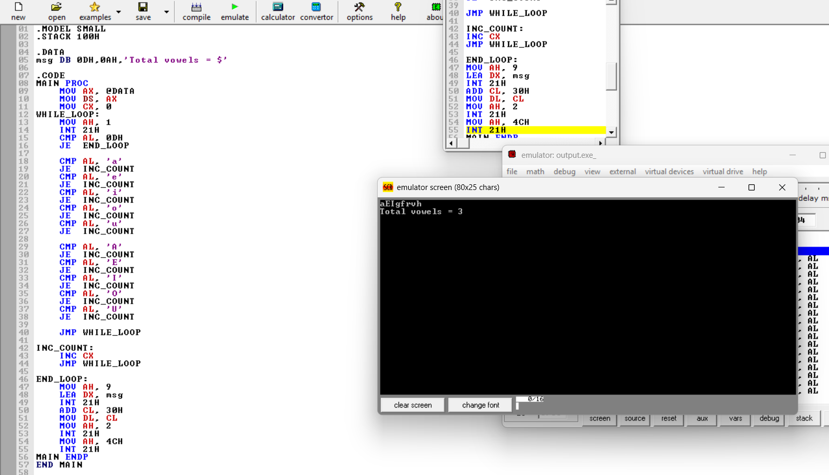
4) Write an assembly program using a REPEAT–UNTIL loop that reads characters until a digit (0–9) is found. - When a digit is detected, display: 'Digit found: X'

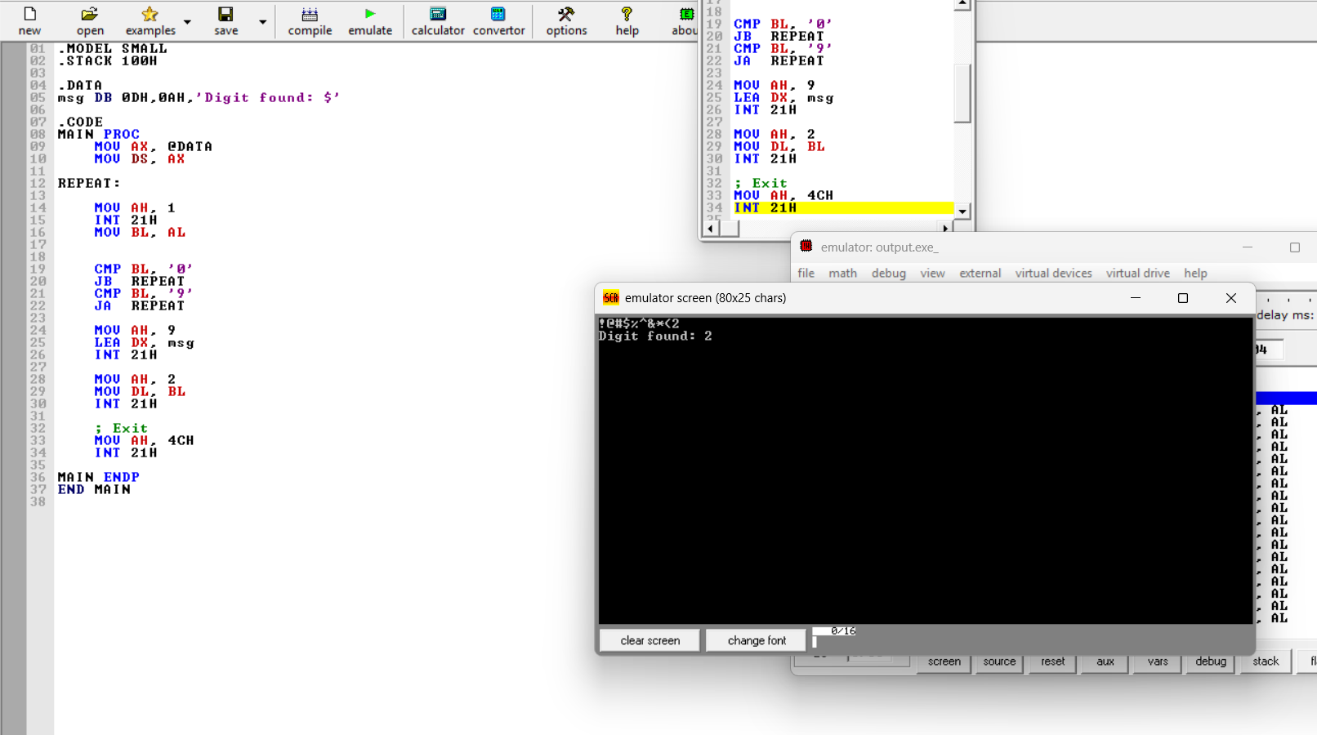

5. Write an assembly program to count the number of words in a line. - A word is defined as a sequence of characters separated by spaces - Use WHILE loop with state flags to detect transitions Display total word count at the end

